**Assignment #4**

**Introduction to Linux**

**Ammad Ali**

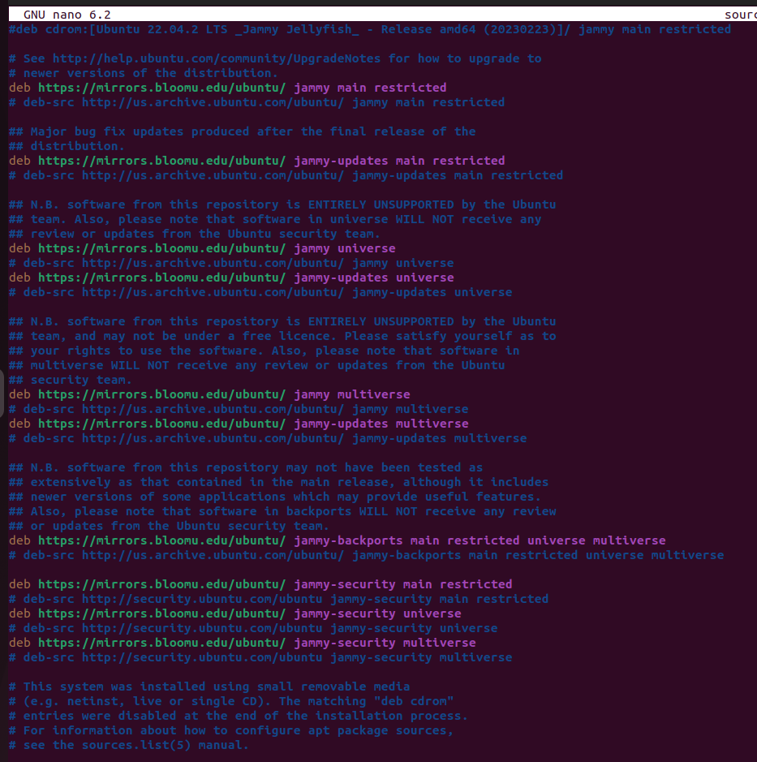

First of all, I opened the sources.list file as sudoer and edited the URLs already written to https://mirrors.bloomu.edu/ubuntu.

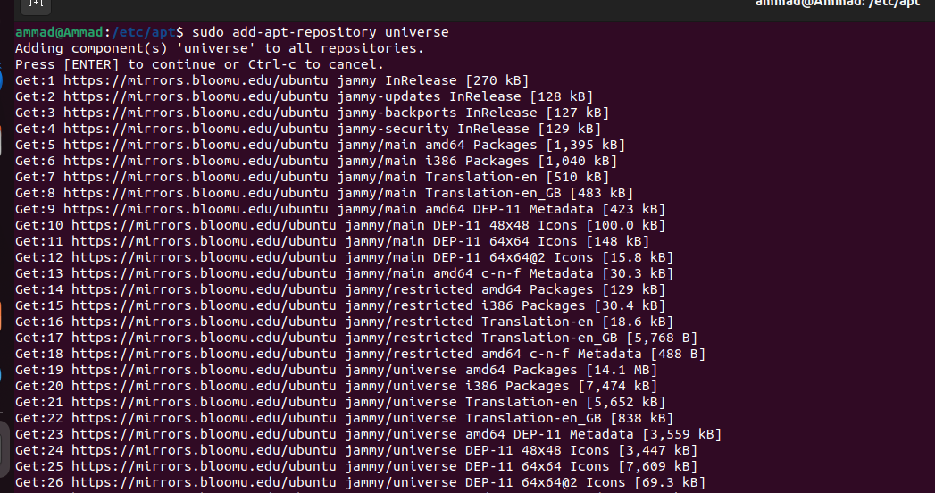

As pandas wasn’t already installed on our system, I tried install it it using apt-get but got an error “unable to locate package python3-pandas”. To fix that, I ran the command sudo add-apt-repository universe. Universe is a warehouse including a wide range of third-party software packages, libraries, and tools that are open source and maintained on a community basis.

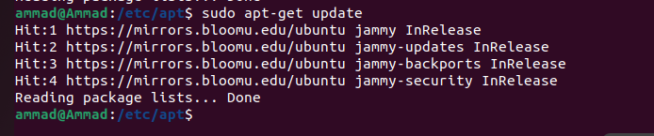

I than updated the list of packages installed on my system with the information of the newest versions available for those packages using sudo apt-get update command.

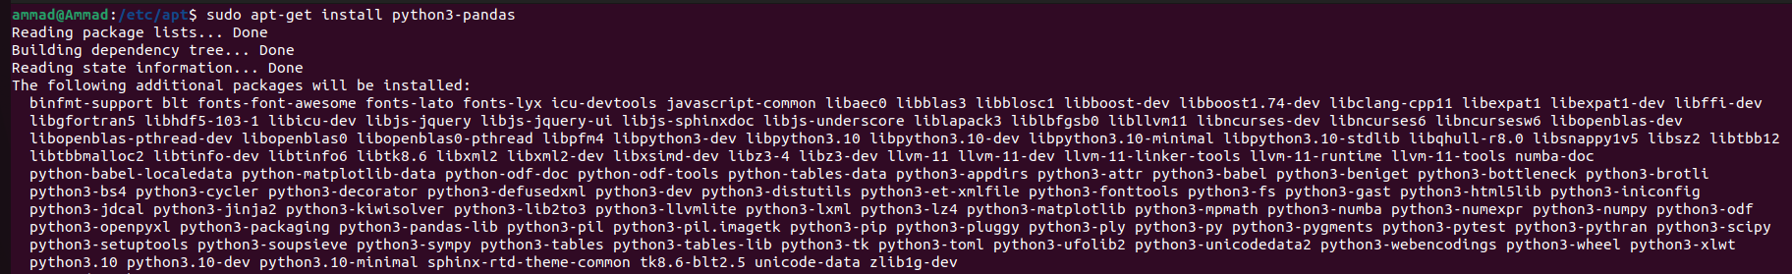

After updating the list, I ran the command sudo apt-get install python3-pandas to install pandas library.

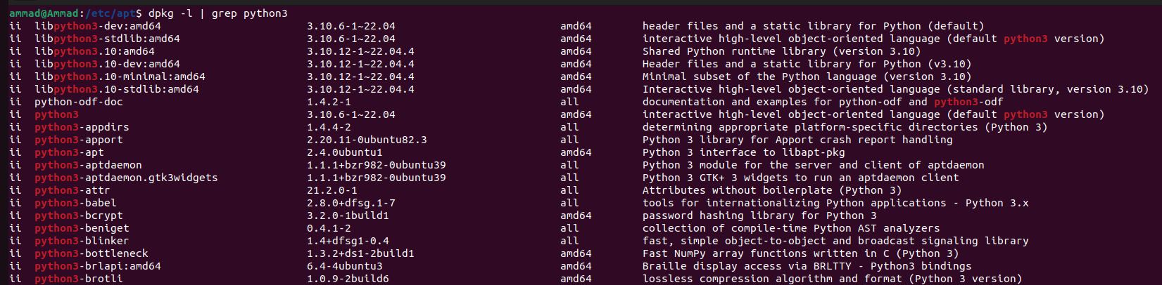

Using the dpkg command branched with grep, we can list down all the python packages installed.



We can run the same command but this time updating the name to search to python3-pandas to search for pandas package.

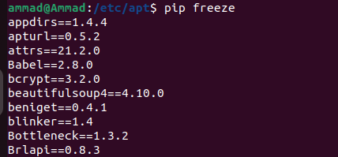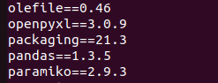

We can also use pip to check if pandas is installed or not and which version is installed.

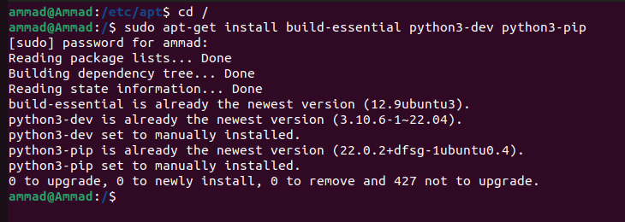

Installing required libraries for building a package using source code.

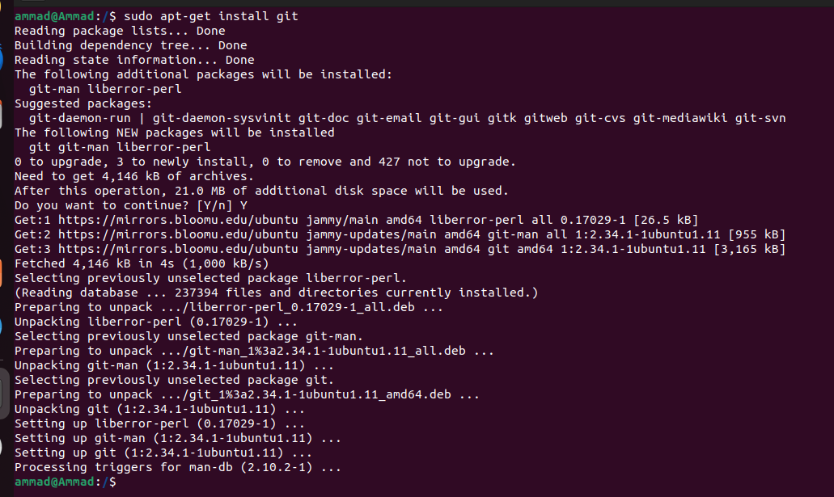

As I am installing scikit-learn using its source code, I needed to pull the source code from github so I installed git.

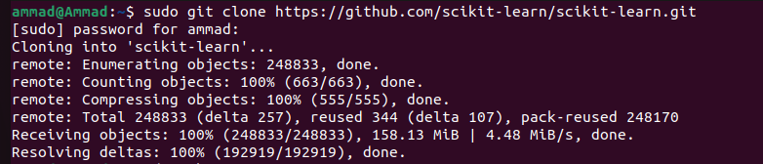

I cloned the scikit-learn repository from github.

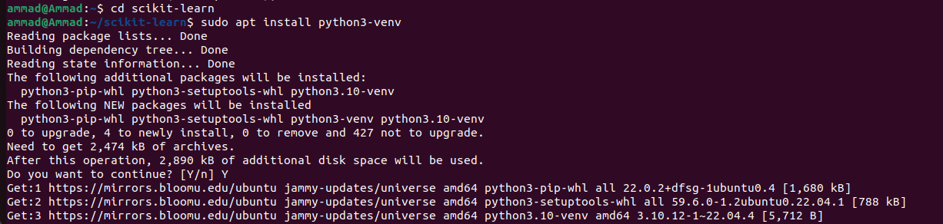

To save all the libraries, I installed python venv.

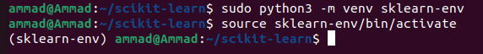

To save all the libraries, I created a new virtual environment for sklearn.

Activating the venv.

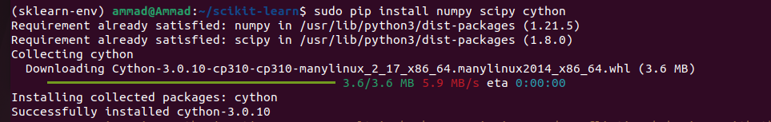

Installing prerequisite libraries for scikit learn and building

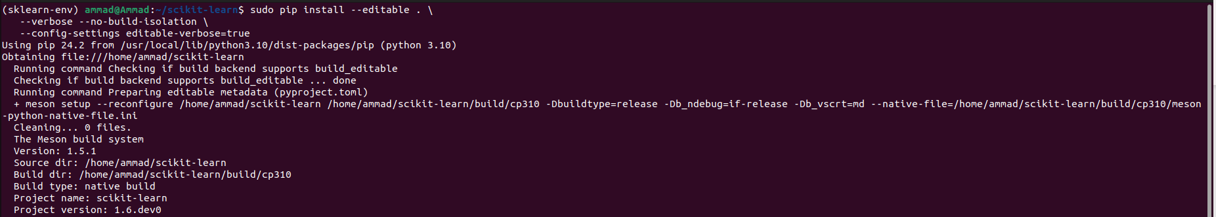

Running the command to build the package and install.



Package successfully installed.

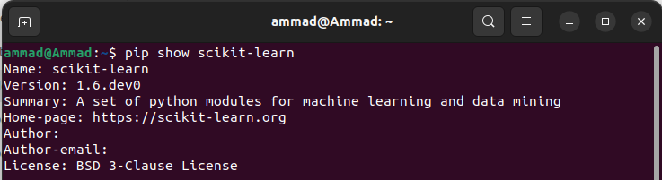

Using pip show to show the installed version